Communication and Language  - Engage in storytimes  - Understand how to listen carefully and understand why listening is important  - Learn new vocabulary  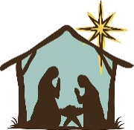  - Describe events in detail  Reception Class Autumn 2 2023  ‘Bright Sparks’  Bonfire night/ Diwali/ Birthdays/Christmas |  | Physical Development    - Revise and refine fundamental movement skills  - Develop overall body strength  - Demonstrate strength, balance  - and co ordination  - Develop small motor skills  Fitness-  PE- Gymnastics Thursdays  Bike/ scooters daily Bike training Nov 1st  Daily track run  Stunning start-Fireworks celebration Mon 30th Oct  Fabulous Finish – Christmas party Fri 15th Dec  Christmas performances 5th & 6th Dec |  | Personal, Social and Emotional Development  - feelings and consider feelings of others  - Show confidence and try new activities  - Manage own needs  - Further develop skills they need to manage the school day successfully- lining up/queuing/mealtimes/personal hygiene  RE Prophecy & Promise  Understanding the Christmas story and why we celebrate Christmas.
Literacy  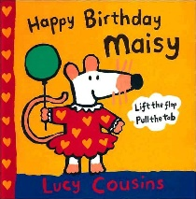  -Listen and talk about stories and build up familiarity and understanding  Anticipate where appropriate key events in stories  Read individual letters  Form some lower case letters  Daily Phonics- Little Wandle  RSHE Ten Ten Module 2 me My Body My Health/ Emotional Well Being  Music with Miss Woodcock | Mathematics  Daily maths sessions focused on the objectives from NCTEM Mastering Number  -focus on counting skills /on the ‘five-ness of 5’ using one hand and the die pattern for 5  -comparison of sets - by matching /Use the language of comparison: more than, fewer than, an equal number  - explore the concept of ‘whole’ and ‘part’  - focus on the composition of 3, 4 and 5  - practise object counting skills  -Match numerals to quantities within 10 Verbal counting beyond 20  Mindfulness- 5 min daily session after lunch |  | Understanding the World  - talk about the lives of people around them and their roles in society  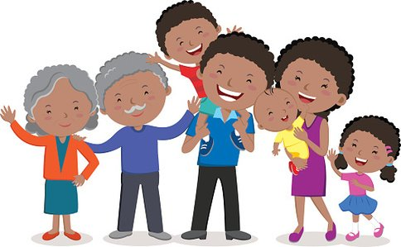  - understand that some places are special to members of their community |  | Expressive Arts and Design  - Explore different materials freely in order to develop their ideas about how to use them and what to make  - Sing in a group or on their own  - Explore and engage in music making and dance performing solo or in a group

